WEEK 1 TASK
Data Science Project Planning and Strategy Design
Hypothetical Project:
Predicting Crop Yield Using Weather and Soil Data for Small-Scale Farmers
Data Science Internship – Project Planning & Strategy Report

1. Introduction & Background
Agriculture remains one of the most weather-dependent and risk-exposed sectors of the economy, and unpredictable crop yields directly affect farmer income, food security, and supply-chain planning for downstream buyers. Small-scale farmers in particular often lack access to data-driven forecasting tools that larger commercial farms use, relying instead on traditional knowledge and seasonal experience alone.
Problem Statement: Given the increasing availability of open weather, soil, and historical agricultural datasets, there is a clear opportunity to apply data science techniques to forecast crop yield ahead of the harvest season, giving farmers and local cooperatives a data-backed basis for planning inputs, storage, and sales.
This project proposes a hypothetical data science initiative that ingests historical rainfall, temperature, and soil-quality data alongside past yield records to build a predictive model for crop yield at the district level. Python has been chosen as the implementation language throughout, owing to its extensive ecosystem of data manipulation, visualization, and machine-learning libraries.

1.1 Motivation & Justification
- Yield volatility caused by erratic rainfall and temperature patterns is a growing concern under changing climate conditions.
- Predictive tools that are simple, explainable, and low-cost can meaningfully improve planning for smallholder farmers and agricultural cooperatives.
- Open government and meteorological datasets make this problem tractable without requiring proprietary or expensive data sources.
- The problem naturally spans the full data science lifecycle — collection, cleaning, exploration, modeling, and evaluation — making it well suited for this planning exercise.

2. Project Objectives & Scope

2.1 Objectives
- Design a reproducible pipeline to collect and consolidate weather, soil, and historical yield data for a defined region.
- Build and compare multiple predictive models (regression and ensemble-based) to estimate crop yield ahead of harvest.
- Identify the most influential factors driving yield variation using explainability techniques.
- Produce a clear, non-technical summary of findings suitable for agricultural extension officers and cooperative leaders.

2.2 Scope Definition
In Scope | Out of Scope
District-level yield prediction for three staple crops (wheat, rice, maize) using historical weather and soil data | Real-time satellite imagery analysis or remote sensing integration
Use of publicly available government and meteorological datasets | Mobile or web application development for farmers
Model comparison across regression, tree-based and ensemble methods | Pest and disease outbreak prediction
Explainability of predictions using feature-importance techniques | Deployment to production infrastructure or cloud hosting
Table 1: Project scope boundaries

3. Methodology & Strategy
The project follows a standard, iterative data science lifecycle. Each stage feeds into the next, with a feedback loop back to problem definition once initial results are evaluated — allowing the scope or features to be refined if early results suggest the model is underperforming or the problem needs reframing.
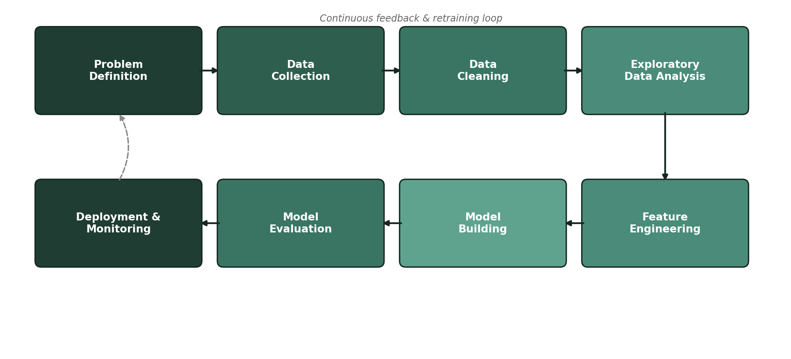
Figure 1: End-to-end methodology and feedback loop

3.1 Data Collection Strategy
Historical rainfall and temperature data would be sourced from meteorological department archives, soil composition data from agricultural survey records, and past yield figures from government crop production reports. All sources would be joined on a common district and season key.

3.2 Data Cleaning Strategy
- Standardize date formats and district naming conventions across all three data sources before merging.
- Impute missing rainfall or temperature readings using seasonal averages for the same district.
- Flag and review yield outliers that fall outside three standard deviations from the district mean.
- Encode categorical fields such as crop type and soil category for downstream modeling.

3.3 Exploratory Analysis Strategy
Univariate analysis would examine the distribution of yield, rainfall, and temperature independently. Bivariate and multivariate analysis would explore correlations between weather variables and yield, and interaction effects between soil quality and rainfall. Seasonal and year-over-year trends would be visualized to detect any long-term climate impact on yield.

3.4 Modeling & Evaluation Strategy
Multiple model families would be trained and compared: a linear regression baseline, a random forest regressor, and a gradient-boosted model (XGBoost). Cross-validation would be used to tune hyperparameters and reduce overfitting risk, given the relatively small size of typical agricultural datasets.

4. Timeline & Tools
The plan below allocates the recommended 30–35 hours of Week 1 effort across the planning and design activities. Since no dataset is used this week, the hours reflect research, strategy design, and documentation effort rather than hands-on coding time.
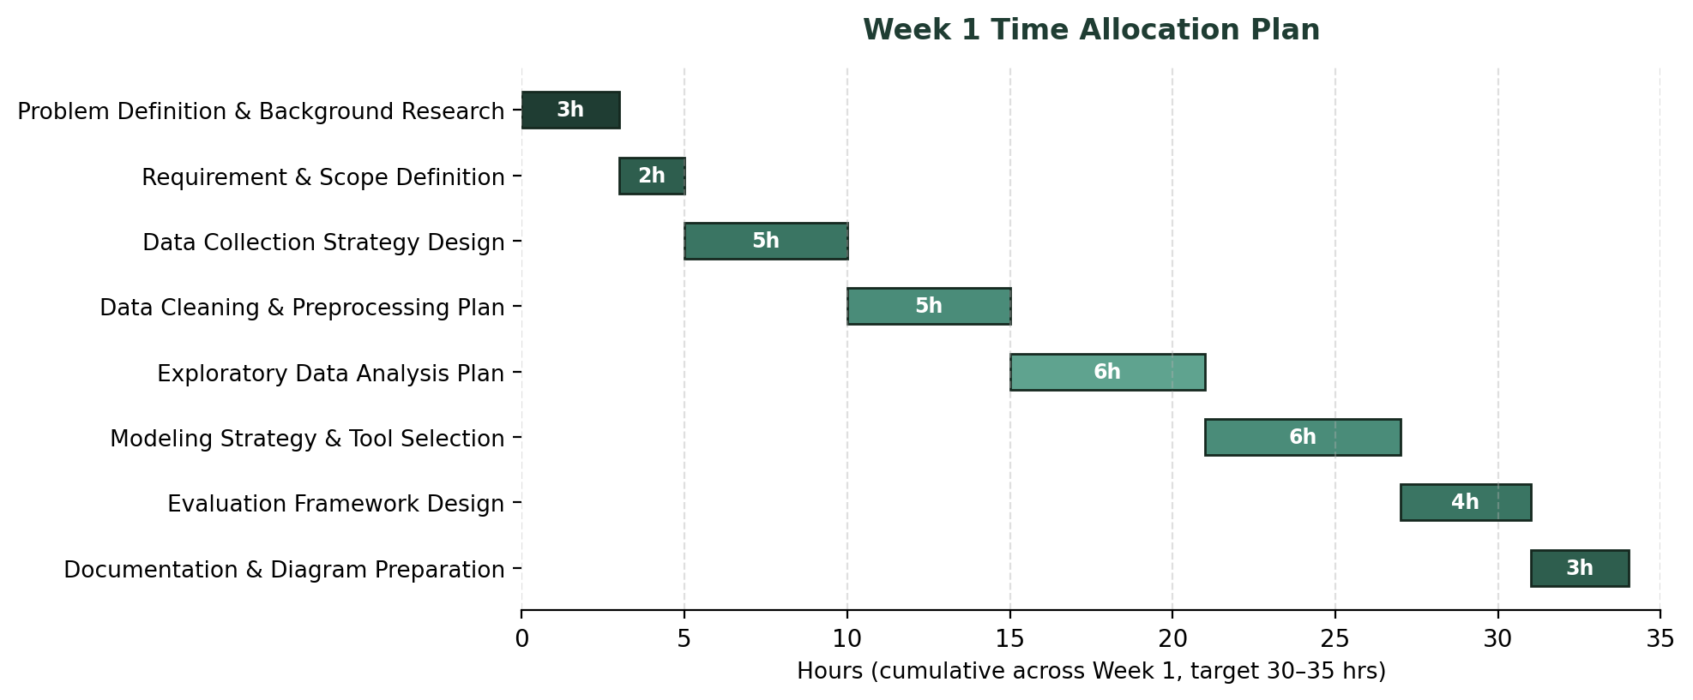
Figure 2: Week 1 time allocation across planning activities

4.1 Tools & Libraries
Stage | Libraries / Tools | Purpose
Data Collection | pandas, requests, SQLAlchemy, OpenWeatherMap API | Pull historical weather, soil and yield records from public agricultural datasets and APIs
Data Cleaning | pandas, NumPy, missingno | Handle missing values, correct data types, remove duplicate or inconsistent entries
Exploratory Analysis | matplotlib, seaborn, plotly | Visualize distributions, correlations and seasonal trends in the data
Modeling | scikit-learn, XGBoost, statsmodels | Build regression and ensemble models to predict yield
Evaluation | scikit-learn (metrics), SHAP | Score model performance and explain feature importance
Environment | Jupyter Notebook, Git/GitHub, VS Code | Development, version control and reproducibility
Table 2: Python libraries and tools mapped to each project stage

5. Expected Outcomes & Challenges

5.1 Expected Outcomes
- A working predictive model that estimates crop yield with a quantified margin of error ahead of harvest.
- A ranked list of the factors (e.g., cumulative rainfall, soil pH, sowing-to-harvest temperature range) most predictive of yield.
- A reusable data pipeline that can be extended to additional crops or regions in future iterations.

5.2 Anticipated Challenges & Mitigation
Challenge | Mitigation Strategy
Inconsistent or sparse historical data across districts | Aggregate to a coarser regional level where district-level data is too sparse; use interpolation for short gaps
Small sample size limiting model generalization | Favor simpler, regularized models and robust cross-validation over complex deep-learning approaches
Weather variability not captured by historical averages alone | Include derived features such as rainfall variance and drought/excess-rain indicators, not just monthly means
Model results being difficult for non-technical stakeholders to trust | Use SHAP-based explainability plots and plain-language summaries alongside technical metrics
Table 3: Risk register for the proposed project

6. Conclusion
This plan lays out a complete, structured approach to a crop-yield prediction project — from problem framing through to evaluation — designed to be executed entirely in Python. The methodology emphasizes reproducibility, explainability, and practical relevance to end users, providing a solid foundation for the technical implementation tasks in the following weeks of this internship.

